Day 1 – THE VANISHING WORKFORCE: Where did all the workers go?

Pre-Pandemic: (“Perfect Storm”)
_______________________________________________________________________________________________________________________________________________________________________________________________________________________________________________________________________________________________________________________________________________
Current Situation: (“Landfall”)
_______________________________________________________________________________________________________________________________________________________________________________________________________________________________________________________________________________________________________________________________________________
Post Pandemic: (“Aftermath”)
_______________________________________________________________________________________________________________________________________________________________________________________________________________________________________________________________________________________________________________________________________________
Notes:
__________________________________________________________________________________________________________________________________________________________________________________________________________________________________________________________________________________________________________________________________________________________________________________________________________________________________________________________________________________________________________________________________________________________________________________________________________________________________________________________________________________________________________________________________________________________________________________________________________________________________________________________________________________________________________________________________________________________________________________________________________________________________________________________________________________________________________________________________________________________________________________________________________________________________________________________________________________________________________________________________________________________________________________________________________________________________________________________________________________________________________________________________
Day 2: Becoming an Employer of Choice

- _____________________________
- _____________________________
- _____________________________
Employee Benefits: _____
__________________________________________________________________________________________________________________________________________________________________________________________________________________________________________________________________________________________________________________________________________________________________________________
Revisit Job Descriptions: _____
__________________________________________________________________________________________________________________________________________________________________________________________________________________________________________________________________________________________________________________________________________________________________________________
Onboarding: _____
__________________________________________________________________________________________________________________________________________________________________________________________________________________________________________________________________________________________________________________________________________________________________________________
Training and Development (including leadership): _____
_________________________________________________________________________________________________________________________________________________________________________________________________________________________________________________________________________________________________________________________________________________________________________________

Workforce Planning: _____
__________________________________________________________________________________________________________________________________________________________________________________________________________________________________________________________________________________________________________________________________________________________________________________
Career Pathways: _____
__________________________________________________________________________________________________________________________________________________________________________________________________________________________________________________________________________________________________________________________________________________________________________________
Untapped Talent: _____
__________________________________________________________________________________________________________________________________________________________________________________________________________________________________________________________________________________________________________________________________________________________________________________

Stay Interviews: _____
__________________________________________________________________________________________________________________________________________________________________________________________________________________________________________________________________________________________________________________________________________________________________________________

Next Action Steps: Questions to consider as you disrupt, obsess and crusade!

- On a scale of 1-10, how committed are we to disrupt, obsess and crusade?

- What do we want our employer of choice brand to say to employees? Potential Candidates? Community?

- What do we need to do to disrupt our mindset to think differently?

- What area(s) can we work on first which would best leverage our immediate challenges? (Think 3-6 months)

- What areas do we need to concentrate on after the first 6 months? (Goal for the end of ’22? ’23?)

- What will we do differently to obsess about retention?

- What will we do differently to obsess/crusade for training and development?

- How will we roll out an “employer of choice” culture to the entire organization?

- What can we do to keep from falling back into old ways of thinking that are not aligning with our employer of choice mindset?

- What will be our biggest hurdles as we crusade forward?

- What resources will we need to help us through making changes?
For more information about staffing needs, scan the QR code: OR
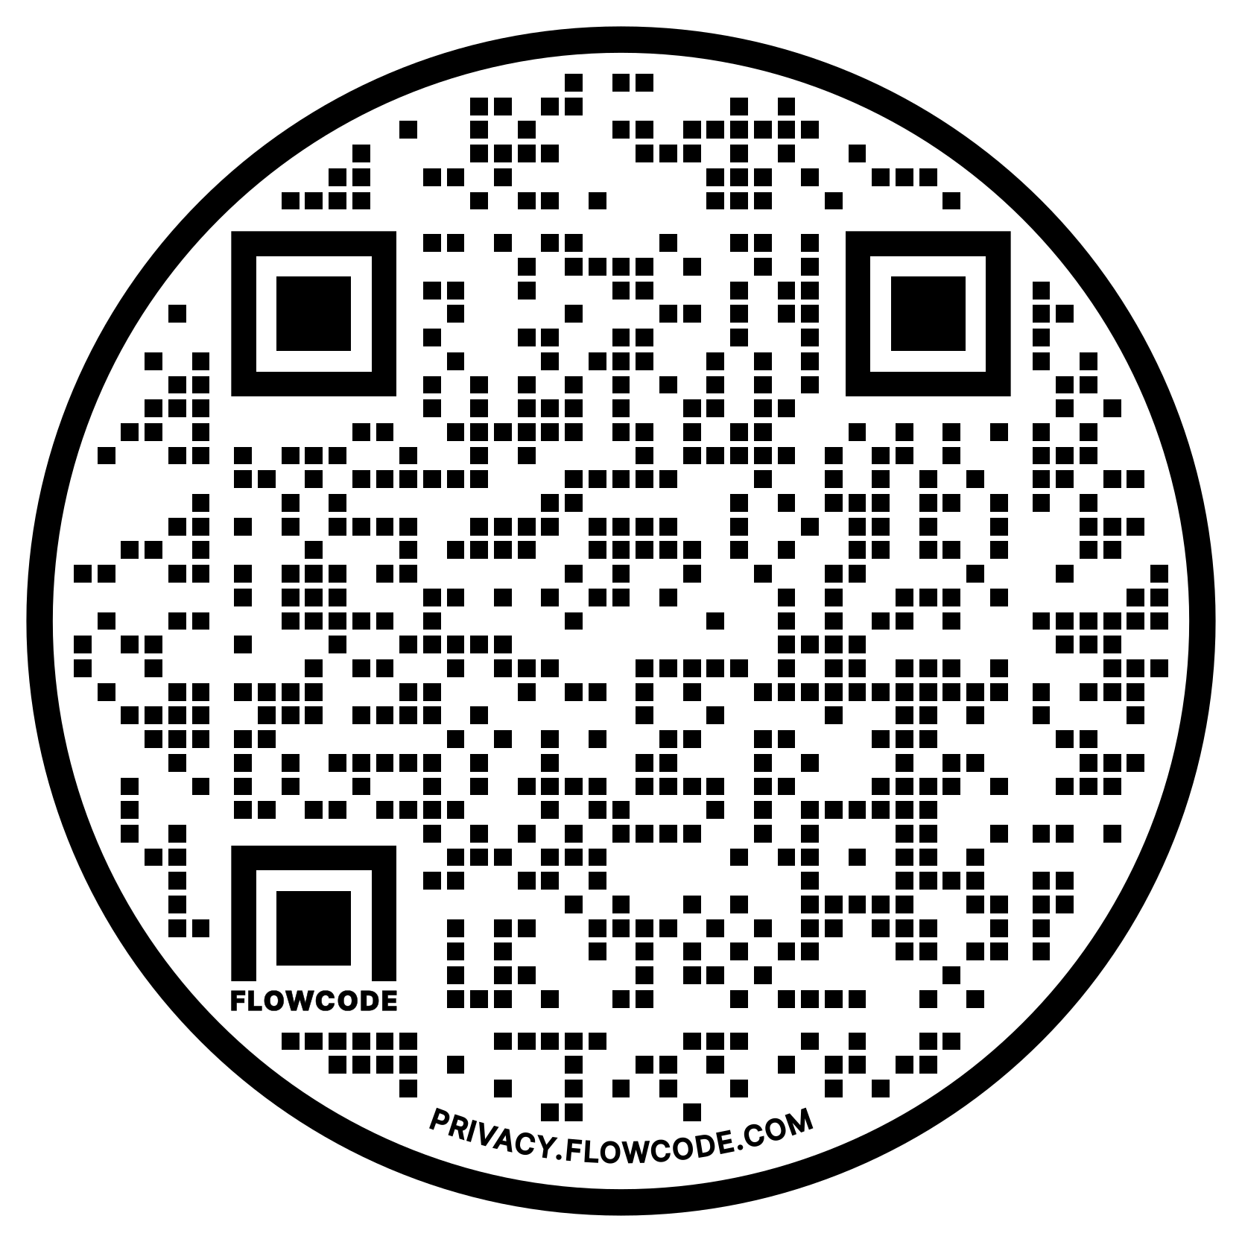
Call Pat or Renee Ashworth
(307) 263-1430
(3

Email Lorraine Medici at
Lorraine.medici@expresspros.com
For more information about training, coaching and consulting, scan the QR code: OR

Email Lorraine Medici at
Lorraine.medici@expresspros.com

